Intermestic Determinants Influencing Indonesia's Vision To Become The Global Halal Hub

Rizki Dian Nursita

¹ Universitas Islam Indonesia, Yogyakarta

Corresponding Email: rizki.dian.nursita@uii.ac.id

 | Abstract
Article History:  Received: Oct 7, 2024  Revised: Dec 24, 2024  Accepted: Mar 3, 2025  Published: July 31, 2025 | Islam has been the fastest-growing religion in the last decades. The world's Muslim population has reached 1.9 billion people by 2022. Such growth makes Muslims the most influential segment in the global industry, particularly the global halal industry. The halal industry is not only a matter of food but has become a lifestyle. Facing such a challenge, Indonesia has taken ambitious steps to become the Global Halal Hub. Among them are by issuing Law No. 33 of 2014, Indonesia Islamic Economic Masterplan 2019-2024, Government Regulation No. 39 of 2021, Ministerial Regulation No. 20 of 2021, and changing the governance of national halal certification and standardization. The government has become more serious about its ambition in the halal industry by declaring a vision to become the Global Halal Hub. This study tries to explain the intermestic factors influencing Indonesia's halal policy transformation. The results of this study show that domestic and international factors influence the transformation in Indonesia’s halal policy. Domestic factors comprise the halal values ​​in the consumption behavior of Muslims in Indonesia, the shift in the domestic policy by centralizing halal certification, and competition among stakeholders in governing halal certification in Indonesia. The international factors comprise the global halal standards, the vigorous competition in the halal industry between Indonesia and the neighboring countries, such as Malaysia, Brunei Darussalam, Singapore, and Thailand, and between Indonesia and major players of the global halal industry, such as Brazil, India, and the United States..
Keywords: Halal Hub, Halal Industry, Indonesia, Intermestic

I. INTRODUCTION
Muslims are one of the largest religious groups in the world. Based on data from World Population Review, the world's Muslim community has reached 1.9 billion people. Islam can be considered the fastest-growing religion in recent years. The growth makes Muslims the most influential segment globally, especially the halal industry. People have started to be aware that halal is not limited to food; it is also a Muslim lifestyle. The ‘halal’ label is also often associated with financial services, media, marketing, electronics, fashion, and hospitality.
The global halal industry is now a promising sector worldwide. According to the 2019 State of the Global Islamic Economy Report, it is estimated that Muslims worldwide have spent 2.2 trillion USD on food, fashion, media and entertainment products, tourism and travel, pharmaceuticals, and cosmetics influenced by Islamic values and teachings. This amount does not include the financial sector of USD 2.5 trillion. Among these sectors, the financial and food sector is the most vital sector that has the highest global spending (see Figure 1).

Figure 1. Estimated Global Muslim Expenditure in Islamic Economic Sector

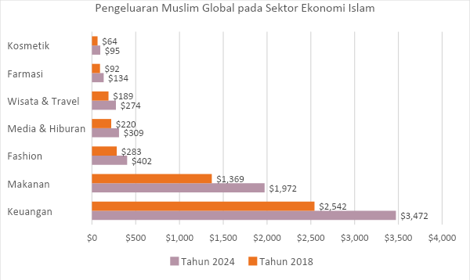
Source: DinarStandard, 2019
This number is expected to increase by around 2 trillion USD, from 4.7 trillion to 6.7 trillion in 2024. Market demand for products that meet sharia compliance standards is unavoidable since Muslims see religion as a very influential factor in life. This increase was also driven by an increase in global Muslims from the middle-class segment.
Indonesia and Malaysia can be said to be one step ahead in governing the halal sector. Since 1989, Majelis Ulama Indonesia (MUI) has established Lembaga Pengkajian Pangan, Obat-obatan, dan Kosmetika (LPPOM); MUI’s body that be responsible for ensuring halal status for food, drugs, and cosmetics in Indonesia. Thus, the market for halal products in Indonesia grows by 7% to 10% per year. However, halal governance has been managed by this NGO for decades.

II. METHODOLOGY
This research employs a systematic literature review method. A systematic literature review is a research method used to identify and synthesize literature relevant to a specific research topic. In this case, the researchers aim to identify literature related to “Indonesia” and the “Global Halal Hub” in recent years, as published and archived in Google Scholar, with the assistance of third-party software. The literature review was conducted by analyzing metadata containing the following keywords: 'politics', 'halal', 'global', and 'Indonesia'. The word cloud below shows that only a small amount of research discussing Indonesia in global halal politics was published from 2019 to 2022 (See Figure 3).

Figure 3. Research Related to Politics of Global Halal Published between 2019-2022
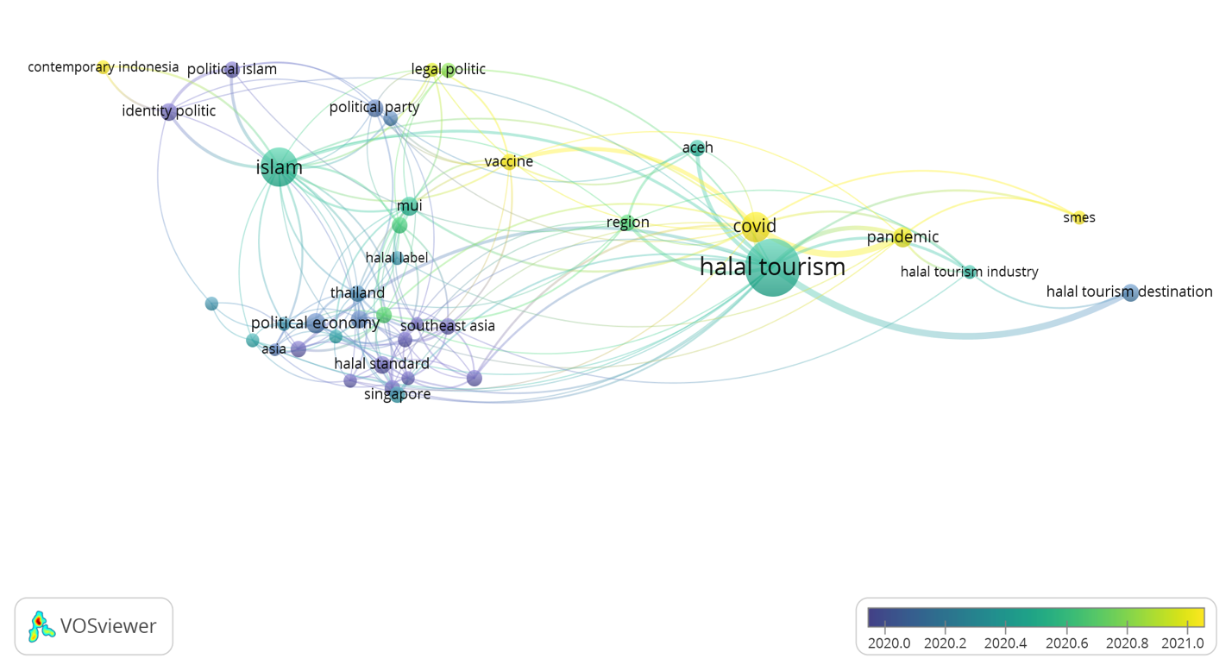

The word cloud above also shows that most of the research conducted between 2019-2022 discussed more 'halal tourism'; there are other relevant issues related to halal politics, such as political Islam, identity politics, political parties, covid, and SMEs. Some publications on halal tourism took Thailand, Singapore, Japan, and Indonesia as a study cases, and regional cases, Asia and Southeast Asia. The word cloud also shows that no research discusses Indonesia’s policy or other relevant countries in pursuing the goal of becoming the global halal hub.
By using a manual search of the previous publications; there are not many journals related to this article; among them is 'Positioning Malaysia as Halal-Hub: Integration Role of Supply Chain Strategy And Halal Assurance System' written by Muhammad, Isa, and Kifli, The article discusses strategies that enable Malaysia to become a Global Halal Hub. The results of this study indicate that the position of the Global Halal Hub can be achieved by strengthening supply chain strategies, halal assurance, and marketing used by companies. This study also finds a lack of theory that can properly address the three strategies.
Research written by Azam and Abdullah, 'Global Halal Industry: Realities and Opportunities' elaborates on the current situation of the global halal industry and the factors that influence the rapid growth of the global halal market. The results of this study indicate that three factors influence the fast growth of the global halal industry—first, the rapid growth of the Muslim population. Second, the economic growth and purchasing power of the world's Muslim population. Third is the emergence of countries with many Muslim minorities; non-Muslim countries as potential markets and players in the halal industry business. The study clearly shows the halal industry is not exclusively relevant to Muslim segments but also the non-Muslims.
Besides the two articles, a journal by Sidqi and Ruhana, Intermestic Factors in Indonesia Halal Certification, elaborates on international and domestic factors influencing the Indonesian halal certification. The result of the study shows that halal certification for export products is considered a trade barrier for some countries. The issue was discussed in some WTO forums and the Dispute Settlement Body Panel. This study also sees that international dynamics can be dangerous for halal compliance. The international dynamics can allow more permissive halal regulation to keep up with the demands of the international industry.
Indonesia vision to become the Global Halal Hub can be analyzed using an intermestic approach. This research is conducted based on the assumption that the Indonesian government also learns and observes international dynamics and best practices from several countries that make the Global Halal Hub a feature of their global political economy.
Three approaches are often used in analyzing changes in a country's policy; they are 1) the traditional approach, 2) the international approach, and 3) and transnational approach (Kurniawati, 2012). The domestic and international approaches explain that every policy change is always influenced by the motivation or interests of the actor. In contrast, the transnational approach sees that the ideational factor is the main determinant in policy change. The intermestic approach tries to bridge the gap between the three approaches (See Figure 4). The term ‘intermestic’, which is rooted in the words ‘international and domestic’ was first introduced by Henry Kissinger in 1970 to describe international issues that impact the United States economy. The intermestic approach assumes that policy changes are influenced by both actors in decision-making and ideational factors. The intermestic approach sees policy change as a knowledge transmission process that involves transnational interactions.
Figure 4. Approaches in the Policy Change

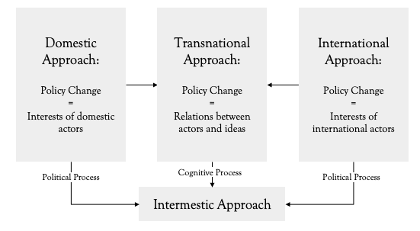

The intermestic approach provides space for state and non-state actors to influence the policy-making process in the domestic and international realms. According to Kurniawati, the intermestic approach can be classified into three approaches: the network approach, the intellectual network approach, the deliberative approach, and the constructivist approach. The network approach emphasizes policy change involving various actors in IR, referred to as an epistemic community, while policy change is said to be a borderless knowledge process. The deliberative approach sees that policy change is caused by the discourse that develops among decision-makers. The constructivist approach sees policy change is a learning process for the actor to adjust to international norms.
There are two perspectives on halal standardization. First, halal standardization can be seen as a policy regulating product quality; products' production, preparation, storage, and marketing should comply with sharia. Second, halal standardization can also be seen as the means or instrument to create a global order. Hence, the intermestic approach is relevant for analyzing the change in halal policy in Indonesia.

III. RESULT AND DISCUSSION

What Halal Means for Indonesia
The Muslim community comprised 86,9 percent of the Indonesian population. Thus, halal consumption has become a habit and lifestyle for Muslims in Indonesia. Besides, halal products are not exclusive to Muslims but can also be consumed by people regardless of their religion. The word "halal" is etymologically derived from the word halla-yahillu means to allow or to be freed. The term halal in Islam means anything permissible according to sharia. Al-Quran mentions fifty-one times the words that have the same root as the word ‘halal’, six of which specifically mention the word "halal", and five are used in verses that refer to halal food consumption and a halal livelihood. A verse in the al-Quran uses "Yā ayyuhan-nāsu" which means "O all humans," to articulate the universality of halal food consumption (al-Quran, 2:168).
Halal certification has made halal consumption among Indonesian people transcended into something else. Majelis Ulama Islam (MUI); a non-governmental organization that represents most of the Muslim community and Islamic organizations in Indonesia and MUI’s agency; Lembaga Pengkajian Pangan Obat-obatan dan Kosmetika (LPPOM) played important roles in governing halal certification in Indonesia since 1996. The awareness of consuming halal-certified food has been increasing. Many food manufacturers are trying to comply with the MUI halal standards. Such developments were further strengthened by the enactment of Ministerial Decrees Number 518 and 519 of 2001 by the Ministry of Religious Affairs.
The two regulations, Ministerial Decree Number 518 and 519 of 2001, identify halal as limited to food products. Halal products have been understood in their broader and comprehensive meaning since Law Number 33 of 2014 was issued. Indonesian regulation embeds the term "halal" to define goods or services related to food, beverages, pharmaceuticals, cosmetics, chemical products, biological products, genetically engineered products, and goods used or utilized by the public, which is declared permissible in Islamic law. Business actors from various religious backgrounds are starting to see halal certification as necessary to meet market demands and comply with governmental regulations. Furthermore, the law states that products that enter, circulate, and are traded in the Indonesian Territory must be certified halal. For this reason, it becomes the government's responsibility to implement the Jaminan Produk Halal (JPH) or Halal Product Guarantee.
Several changes in the current Indonesian halal standardization policy also contributed to introducing a more inclusive halal concept. One of those changes stated in Law Number 11 of 2020 or what is more familiar as ‘Omnibus Law’. The law mentions fee waivers for MSMEs to get the halal certification at BPJPH and the elimination of some eligibilities for halal auditors. Such a convenience will give the impression that halal certification is not religious commodification. Furthermore, BPJPH also establishes agencies working for halal supervision at the regional or district level that are accessible by MSMEs.
Apart from the positive changes, the government must face some prejudices. These changes make the halal bureaucracy in Indonesia look "fat." Halal discourse in Indonesia is also inseparable from political, social, and economic contestation, so there is a stigma that halal certification is a struggle over money and power between the government and non-governmental institutions; MUI. Even more worrying, the rate of corruption is still high. Research in 2020 shows that the Indonesian Anti-Corruption Behavior Index (IPAK) reached 3.84 on a scale of 0-5 in 2020. A stigma also comes from the non-Muslim community regarding the economy and politics involving Sharia compliance, such as halal tourism in less Muslim regions, and Islamic banking and finance have been assumed as an Islamization agenda. To ease the stigma, the Ministry of Industry (Kemenperin) stated that halal products are not a religious issue; halal has become a lifestyle that is widely accepted and applied by people around the world regardless of their religion..
The abolition of ‘Muslim believer’ as one of the auditor eligibilities has also been criticized by some Muslim communities. The halal-haram matters will be judged by those who are not Muslims and do not have a sufficient understanding of Islam and will enable the chance for a more permissive and doubtful halal assessment. Even though halal-certified consumption has become a trend, halal-haram matters are part of Islamic teachings.

More Centralized Indonesia Halal Policy
Since 1989, governing the halal policy has been the focus of Majelis Ulama Indonesia (MUI) and its agency (LPPOM MUI). In 1996, MUI and the Ministry of Religious Affairs agreed to sign an MoU regarding the halal certification; this agreement was strengthened with Ministry’s Decree issued in 2001. LPPOM MUI has had more than 20.000 partners spread in 65 countries and cooperated with more than 40 global halal certification agencies.
However, along with the size of the halal industry in Indonesia and the rise of the global halal industry, the government's leadership in the national halal standardization became unavoidable. Under Susilo Bambang Yudhoyono's administration, Indonesia started to transform the national halal standardization policy in 2014. The government issued Law Number 33 of 2014 concerning Guaranteed Halal Products or Penjaminan Produk Halal. This law also established the Halal Product Guarantee Agency (BPJPH). The government's authority in national halal standardization was strengthened after the BPJPH was ratified on October 11, 2017. BPJPH is a governmental body under the Ministry of Religion with an ‘outward-looking’ vision to "Become the World's Leading Halal Product Assurance Provider" by providing the certification service system, guidance, cooperation networks, and improving the quality management. According to Law Number 33 of 2014, in administering Halal Product Assurance, BPJPH has the authority to:
  - Formulate and establish a halal product guarantee policy;
  - Mapping norms, standards, procedures, and criteria for guaranteeing halal products;
  - Issuing and revoking Halal Certificates on foreign products; and
  - Registering Halal Certificates on imported products.

The establishment of BPJPH is not the final effort of the government. In 2019, the government issued Government Regulation Number 31 of 2019, which regulates the implementation of Law Number 31 of 2014, and this was followed by the formation of the Indonesia Islamic Economic Masterplan 2019-2024. The BPJPH framework is as follows:
Figure 4. BPJPH Roadmap
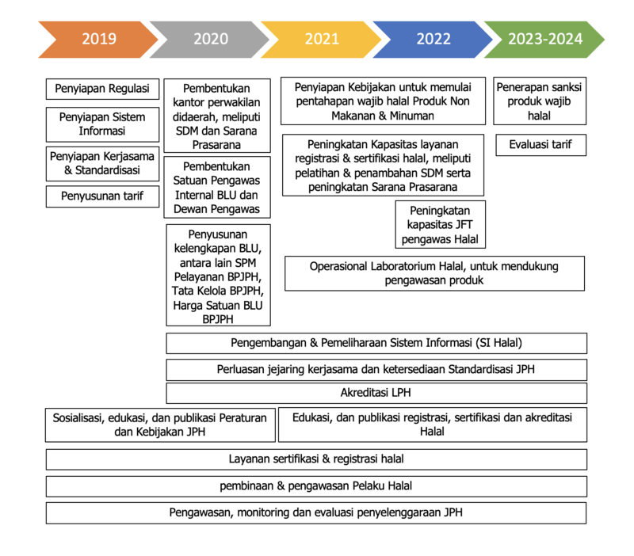
Source: BPJPH

Right after the transformation, Indonesia has not been able to engage in the global halal industry competition optimally. Data from the Global Islamic Economy Index 2018/2019 shows that Indonesia is ranked 10th globally. Although several sectors, such as fashion, food, and halal tourism, Indonesia can excel. However, Indonesia still relies on imported halal products, which caused Indonesia to deal with an economic deficit. However, Indonesia can still manage to catch up with other leading countries in 2019; thus, Indonesia was ranked as the 5th leading country in the Global Islamic Economic Index in 2019.
It is undeniable that the Covid-19 pandemic has hit the economies of countries around the world. The Islamic economic sector is estimated to experience a decline of 8%.. Halal tourism became the most affected sector by the pandemic in Indonesia and other Muslim countries. It’s interesting to know that, amid the pandemic, the Islamic economic sector in Indonesia experienced an improvement. Based on a report from The State of Global Islamic Economic Report (SGIER) 2020/2021, Indonesia's Islamic economy in 2020 is ranked 4th. Still, Indonesia cannot be relieved about this achievement since the level of consumption in Indonesia is high compared to its production. Other countries, such as Malaysia, which was ranked 1st in its Global Islamic Economic Index, have lower consumption levels and high Islamic financial assets compared to other Islamic countries.

Global Halal Standards
Harmonizing the global halal standards is not easy to achieve due to the Muslim countries’ egocentrism. There is a notion that national halal standards are trade barriers and often lead to blunders and inconsistencies. However, several efforts have been made to harmonize global halal standards in certain products and services. Codex Alimentarius Commission (CAC); a collaboration of the Food and Agriculture Organization (FAO), the World Health Organization (WHO), and the International Standards Organization (ISO), issued some criteria for halal food. CAC accepts and recognizes Islamic views on halal (lawful) and haram (unlawful). There are three points in halal food standards that CAC regulates; first, the criteria of halal food, beverages, and food additives; second, the standards of the slaughtering process; and third, standards of preparation, processing, distribution, and storage of halal products.
Organization of Islamic Cooperation (OIC); an IGO of 57 Muslim-majority countries, through The Standards and Metrology Institute for Islamic Countries (SMIIC), has tried to harmonize halal standards in some sectors, including halal food, halal cosmetics, halal tourism, halal supply chain, halal food additive, and other sectors. Indonesia, through Badan Standarisasi Nasional (BSN) or the National Standardization, has agreed to be bound by the following standards:
- TC1 Halal Food Issues
- TC2 Halal Cosmetic Issues
- TC5 Tourism and Related Services
- TC9 Textiles and Related Products
- TC10 Halal Supply Chain
- TC11 Halal Management Systems
- TC16 Halal Pharmaceuticals Issues
These efforts in harmonizing global halal standards undeniably influence Indonesia’s policy on halal; hence some adjustments have been made by the Indonesian government and stakeholders. The trade dispute between Indonesia and Brazil over Brazil’s poultry has forced Indonesia to review its halal policy. Law Number 33 of 2014 is considered too rigid and burdensome for industries and exporting countries. The government, therefore, moderated its halal standards by issuing Government Regulation Number 31 of 2019 to ensure Indonesia's compliance with international trade agreements and Indonesia’s opportunity to join the global competition in the halal industry.

Competition at Regional and Global Levels
- Regional Competitors
Malaysia and Singapore are the leading countries in implementing global halal politics at the regional level. Government authorities in both countries not only focus on certification and bureaucratization of halal products, but they can also expand halal management best practices as a ‘trademark’ in their foreign policy. This allows other countries to adopt the halal standardization model applied by the two countries. Malaysia, for example, in pursuing its ambition to become a global halal hub, collaborated with 57 OIC member countries in halal standardization management and developed the International Halal Integrity Alliance (IHIA). OIC’s COMCEC collaborated with the International Standardization Organization (ISO) and the Codex Alimentarius Commission to harmonize the global halal standards.
Malaysia's strong reputation in halal standardization compared to other Islamic countries has made Malaysia become a role model for some European countries. Malaysia's hegemony in the halal sector in the European Union extends and opens cooperation with the governments and micro and private institutions. In Asia, Japan has implemented an MoU with Malaysia to build cooperation in trade and investment in the halal sector, halal certification, halal tourism, supply chain development, and supporting ecosystems. South Korea did the same thing. The two countries, South Korea and Malaysia, have cooperated in halal certification and capacity building in the global halal market.
Singapore: a country with a small Muslim population (about 15%), has also played an important role in the halal industry among other ASEAN Muslim countries. According to Fischer, Singapore has applied centralized halal standardization from the beginning. It has been the government’s capacity to regulate the halal-matters. Singapore's success is also supported by training conducted by Majelis Ugama Islam Singapura (MUIS) or the Singapore Islamic Religious Council to introduce Singapore's halal standardization model to industry players.
Amid the complicated debate about governance and bureaucracy of halal certification in Indonesia, Singapore is one step ahead and looks at halal political issues from an outward-looking perspective. Singapore quickly recognizes several challenges in global halal governance: non-isolated regulations, inefficient processes, lack of end-to-end (E2E) supply chain arrangements, and high costs in research and development of non-halal products. Tackling these challenges will be beneficial in establishing a more efficient halal ecosystem.
For Indonesia, the international cooperation that has been built is still limited to bilateral and multilateral cooperation in the export-import of halal products. In 2020, for example, during the Covid-19 pandemic, Indonesia partnered strategically with the Philippines to expand trade in the two halal industries. As was done between Japan and Malaysia. Through G2G (government-to-government) cooperation, Indonesia and the Philippines have agreed to facilitate and facilitate the export-import of halal products.
As a Muslim country in Southeast Asia, Brunei Darussalam certainly does not miss the opportunity to compete and collaborate in the regional halal industry. At the domestic level, Brunei seeks to increase the effectiveness of its microeconomic policies and provide stimulus to businesses. Brunei's vision to become a World Class Halal Trade Hub is interpreted as a collaborative effort by increasing cooperation at the regional level. Brunei also improves its cooperation with several countries in Southeast Asia, such as Indonesia and Malaysia; and targets the increase of FDI.
Meanwhile, Thailand, despite having a Muslim minority, Thailand was ranked as the 12th global exporter of halal products and the 5th largest producer of global halal food. More than 60% of Thailand's halal food products are exported to Muslim countries in Southeast Asia, such as Indonesia, Malaysia, and Brunei Darussalam. Based on data from the Department of Thai Trade Center, MENA, Thailand has specified its halal industry for the culinary sector. This strategy fits Thailand's gastro diplomacy to become “the World's Kitchen”. Halal standardization in Thailand is managed by The Central Islamic Council of Thailand, a government agency responsible for ensuring that Thai halal products comply with procedures in Islamic laws.

- Global Competitors
Indonesia's policy changes in halal governance are also influenced by global competition in the halal industry. Among OIC member countries, United Arab Emirates, Bahrain, and Saudi Arabia are influential countries in the global halal market. However, these countries' economic circulation in the halal sector cannot fully become a benchmark for measuring success in the global halal industry. Global competition in the halal industry becomes even more challenging since countries with less Muslim populations, such as Brazil, India, and the United States, have more halal product exports than Muslim countries (See figure 5).

Figure 5. Top Five Global Halal Exporters
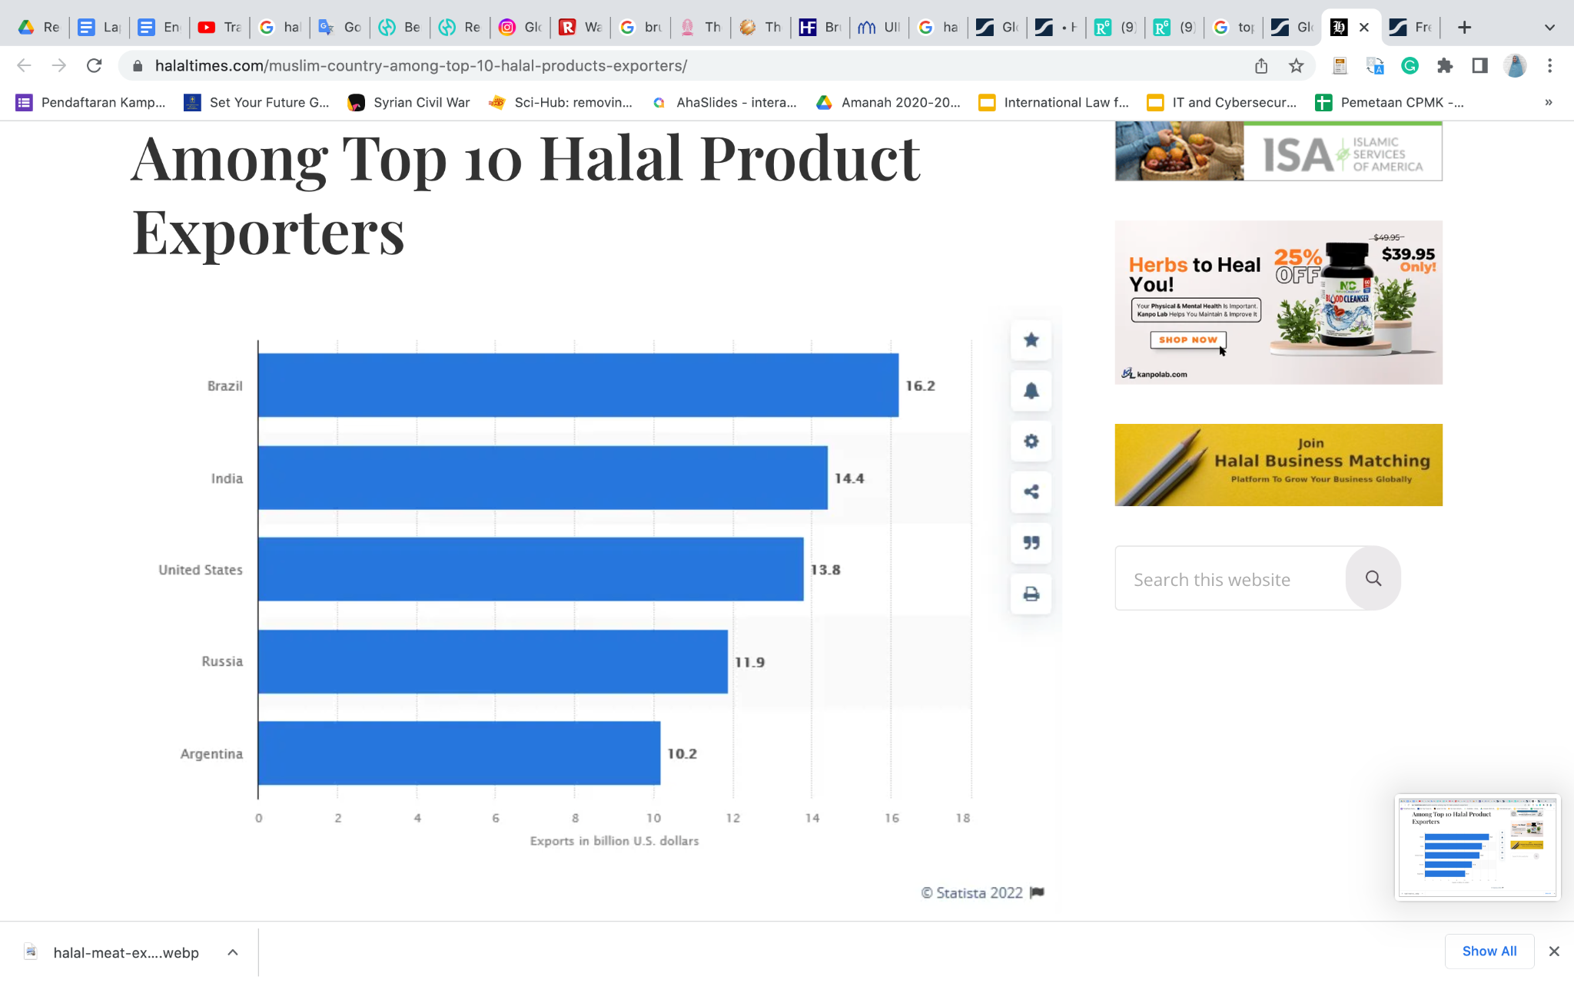
Source: Statista

Brazil contributes greatly to global halal product exports. 2020-2021 shows that Brazil's food exports reached 16.2 billion USD. Most of Brazil's food products meet the food needs of Muslim countries, of which Turkey, Iran, Indonesia, Saudi Arabia, and Bangladesh are the biggest importers of Brazilian foodstuffs. Most of Brazil's export products are halal meat and poultries. Data shows that Brazil's halal beef and chicken exports reached 4.7 billion USD. Data from the last two years shows that Brazil has experienced an increase in exports, and non-Muslim consumers are starting to be interested in halal food for health and hygiene reasons.
Over the past two years, halal food exports from India have increased by more than 50%. Halal certification demand has also increased from 25% to 30% due to the demand from people unsatisfied with non-certified assurance from restaurants and hotels. Data also shows that most of India’s product importers are from Indonesia, Malaysia, and Gulf countries. Besides, halal in India is understood as healthy and hygienic. Thus, many non-Muslims in India also prefer to consume halal products.
The United States also plays an important role in the export of halal products. US position in the global halal is due to several giant US companies, including Safa Foods Ltd., American Foods Group LLC, The American Halal Co. Inc., Barry Callebaut AG, Cargill Inc., Coleman Natural Foods LLC, Crescent Foods, Kronos Foods Corp., Midamar Corp., and Nema Food Distribution Inc. With the high demand from the global market, of course, there are demands for giant companies in the United States to adapt to the needs of consumers, especially consumers in Muslim countries. Although the global halal industry is not the flagship of the United States' global political economy, these companies develop strategies to increase production and expand their presence in the global market. The high export of halal products from the United States is also caused by giant retail companies such as Walmart and Whole Foods, which are spread worldwide.

IV. CONCLUSION
The growth of the Muslim population in the world, especially from the middle class, has contributed to the increasingly massive growth of the global halal industry. Some countries compete to capture this niche opportunity by becoming a Global Halal Hub regardless of their identity and Muslim populations. Indonesia, of course, as the largest Muslim country in the world, cannot ignore this opportunity and challenge to become a player in the global halal industry. This ambition can be observed from several changes carried out by the government related to halal governance, as well as Indonesia’s political economy framework, including the Global Halal Hub.
Domestic and international determinants influence Indonesia’s vision of becoming the Global Halal Hub. Domestic determinants include changes in the understanding of halal products. Halal products are not only limited to food but also other products. Thus, Indonesia’s halal governance becomes more inclusive; and the centralization of halal regulation which previously was the MUI’s capacity, become the government's trademark. This study also shows that there are two factors influencing the change of Indonesian policy, they are efforts made by international organizations (CAC and OIC) in harmonizing the global halal standards, strong competition and/or collaboration between countries at regional and international levels.

V. REFERENCES
Africa Economic Islamic Foundation, The Global Halal Industry: An Overview (Africa Economic Islamic Foundation, 2019), pp. 1–20
al-Ma’aniy, ‘Ta’rif Wa Ma’na Halal Fi Mu’jam al-Ma’aniy’, Al-Ma’aniy <https://www.almaany.com/ar/dict/ar-ar/%D8%AD%D9%84%D8%A7%D9%84/>
Azam, Md Siddique E., and Moha Asri Abdullah, ‘GLOBAL HALAL INDUSTRY: REALITIES AND OPPORTUNITIES’, IJIBE (International Journal of Islamic Business Ethics), 5.1 (2020), pp. 47–59, doi:10.30659/ijibe.5.1.47-59
al-Baqi, Muhammad Fu’ad’Abd, ‘Al-Mu’jam al-Mufahras Li-Alfaz al-Qur’an al-Karim’ (Daar al-Kutub al-Misriyah, 2001)
Bergeaud-Blackler, Florence, ‘The Encounter of Market and Diasporic Dynamics’, in Halal Matters: Islam, Politics and Markets in Global Perspective (Taylor and Francis Inc, 2016), pp. 91–104
Bergeaud-Blackler, Florence, Johan Fischer, and John Lever, Halal Matters: Islam, Politics and Markets in Global Perspective (Routledge, 2015)
BPJPH, ‘Visi Dan Misi Badan Penyelenggara Jaminan Produk Halal (BPJPH)’ <http://www.halal.go.id/profil/visimisi> [accessed 15 July 2022]
BPS, Indeks Perilaku Anti Korupsi (IPAK) Indonesia Tahun 2020 Meningkat Dibandingkan IPAK 2019 (Badan Pusat Statistik, 2020) <https://www.bps.go.id/pressrelease/2020/06/15/1671/indeks-perilaku-anti-korupsi--ipak--indonesia-tahun-2020-meningkat-dibandingkan-ipak-2019.html>
CBRE, ‘About: One-Stop Integrated Halal Hub’, SG Halal Hub, 2019 <https://sghalalhub.com/index.php/about> [accessed 16 June 2020]
Data Indonesia, ‘Sebanyak 86,9% Penduduk Indonesia Beragama Islam’, Dataindonesia.id, 2022 <https://dataindonesia.id/ragam/detail/sebanyak-869-penduduk-indonesia-beragama-islam> [accessed 16 July 2022]
Databoks, ‘Sebanyak 86,88% Penduduk Indonesia Beragama Islam | Databoks’, 2021 <https://databoks.katadata.co.id/datapublish/2021/09/30/sebanyak-8688-penduduk-indonesia-beragama-islam> [accessed 16 July 2022]
Deputy of the Economy Indonesian Ministry of National, ‘Indonesia Islamic Economic Masterplan 2019-2024’, Indonesian Ministry of National Development Planning, 2019 <https://knks.go.id/storage/upload/1560308022-Indonesia%20Islamic%20Economic%20Masterplan%202019-2024.pdf>
DinarStandard, State of the Global Islamic Economy Report 2019/20 (DinarStandard, 2019) <https://cdn.salaamgateway.com/special-coverage/sgie19-20/full-report.pdf>
———, State of the Global Islamic Report 2020/2021: Thriving in Uncertainty, 2020, Salaam Gateway <https://cdn.salaamgateway.com/reports/pdf/8fc62756cf0e10613760a28a8ac816bd7ab42e05.pdf>
FAO, ‘GENERAL GUIDELINES FOR USE OF THE TERM “HALAL”’, 1997 <https://www.fao.org/3/y2770e/y2770e08.htm> [accessed 11 August 2022]
Fischer, Johan, ‘Halal Training in Singapore’, in Halal Matters: Islam, Politics and Markets in Global Perspective (Taylor and Francis Inc, 2016), pp. 175–91
Idris, M, ‘Kemenperin: Halal Bukan Karena Masalah Agama, Sekarang Jadi Fesyen’, Kompas.Com, 25 October 2020 <https://money.kompas.com/read/2020/10/25/074246626/kemenperin-halal-bukan-karena-masalah-agama-sekarang-jadi-fesyen.>
Kurniawati, Dyah, ‘Intermestic Approach: A Methodological Alternative in Studying Policy Change’, PCD Journal, 5 (2017), p. 147, doi:10.22146/pcd.26293
Kusumaningrum, Demeiati N., and Dyah Estu Kurniawati, Intermestik sebagai Pendekatan Studi Hubungan Internasional: Pengantar dan Contoh Penelitian (Penerbit LeutikaPrio, 2016)
Lever, John, ‘The Postliberal Politics of Halal: New Directions in the Civilizing Process?’, Human Figurations, 2.3 (2013) <http://hdl.handle.net/2027/spo.11217607.0002.306>
Lipka, Michael, and Conrad Hackett, ‘Why Muslims Are the World’s Fastest-Growing Religious Group’, Pew Research Center, 2017 <https://www.pewresearch.org/fact-tank/2017/04/06/why-muslims-are-the-worlds-fastest-growing-religious-group/> [accessed 7 June 2020]
LPPOM MUI, ‘Diakui Internasional’, LPPOM MUI | Lembaga Pengkajian Pangan Obat-Obatan Dan Kosmetika Majelis Ulama Indonesia <https://halalmui.org/mui14/main/diakui_internasional> [accessed 15 July 2022]
Mao, Ana, ‘Brazil Eyes $1.17 Trillion Halal Food Market, Keen to Boost Its Share in Trade | Reuters’, Reuters, 2021 <https://www.reuters.com/markets/commodities/brazil-eyes-117-trillion-halal-food-market-keen-boost-farm-trade-with-islamic-2021-12-06/> [accessed 21 July 2022]
Mastercard, Crescentrating, Indonesia Muslim Travel Index (IMTI) 2019 (Crescentrating Mastercard, 2019)
Mcbeth, John, ‘Indonesia’s Halal Law Threatens to Trigger Trade Disputes’, Asia Times, 2022 <https://asiatimes.com/2022/02/indonesias-halal-law-threatens-to-trigger-trade-disputes/> [accessed 11 August 2022]
Ministry of Culture Sports d Tourism and Korean Culture and Information, ‘Malaysia: Global Hub of Halal Industry’, 2019 <http://www.korea.net/NewsFocus/policies/view?articleId=178337> [accessed 16 June 2020]
Ministry of Economy Trade and Industry, ‘Japan and Malaysia Sign Memorandum of Cooperation on Halal Cooperation’, Ministry of Economy Trade and Industry, 2018 <https://www.meti.go.jp/english/press/2018/1127_002.html>
Nik Muhammad, Nik Maheran, Filzah Md Isa, and Bidin Chee Kifli, ‘Positioning Malaysia as Halal-Hub: Integration Role of Supply Chain Strategy and Halal Assurance System’, Asian Social Science, 5.7 (2009), pp. 44–52, doi:10.5539/ass.v5n7p44
Purnomo, W.A., ‘Berebut Kuasa Di Jalur Halal’, Tempo, 15 October 2014 <https://majalah.tempo.co/read/nasional/146289/berebut-kuasa-di-jalur-halal>
Salaam Gateway, ‘India’s Halal Food Industry Sees Major Growth in Export and Domestic Markets’, Salaam Gateway - Global Islamic Economy Gateway, 2021 <https://www.salaamgateway.com/story/indias-halal-food-industry-sees-major-growth-in-export-and-domestic-markets> [accessed 21 July 2022]
Salama, ‘Brunei Confident of Becoming a World Class International Halal Trade Hub’, HalalFocus.Net - Daily Halal Market News, 2020 <https://halalfocus.net/brunei-confident-of-becoming-a-world-class-international-halal-trade-hub/> [accessed 20 July 2022]
Saputra, A, ‘Tak Lagi Punya Otoritas Halal, MUI Gugat UU JPH Ke MK’, Detiknews, 14 August 2019 <https://news.detik.com/berita/d-4664936/tak-lagi-punya-otoritas-halal-mui-gugat-uu-jph-ke-mk>
Shikoh, Rafiuddin, Mian N Riaz, and Munir M Chaudry, ‘Global Halal Economy’, in Handbook of Halal Food Production (CRC Press, 2019)
Sidqi, Adkhilni, and Akmal Ruhana, Intermestic Factors of Indonesia’s Halal Certification, 2021, doi:10.4108/eai.2-11-2020.2305029
SMIIC, ‘National Standardization Agency of Indonesia (BSN)’ <https://www.smiic.org/en/member/48> [accessed 11 August 2022]
The Halal Times, ‘Almost No Muslim Country Among Top 10 Halal Product Exporters’, The Halal Times, 2022 <https://www.halaltimes.com/muslim-country-among-top-10-halal-products-exporters/> [accessed 21 July 2022]
The Trade Arabia, ‘The Rise of Thai Halal Industry’, The Trade Arabia, 2021 <http://www.tradearabia.com/news/IND_387216.html> [accessed 20 July 2022]
Undang-Undang Nomor 33 Tahun 2014 Tentang Jaminan Produk Halal, 2014
World Population Review, ‘Muslim Majority Countries 2022’, 2022 <https://worldpopulationreview.com/country-rankings/muslim-majority-countries> [accessed 12 July 2022]

World Population Review, ‘Muslim Majority Countries 2022’, 2022 <https://worldpopulationreview.com/country-rankings/muslim-majority-countries> [accessed 12 July 2022].
Michael Lipka and Conrad Hackett, ‘Why Muslims Are the World’s Fastest-Growing Religious Group’, Pew Research Center, 2017 <https://www.pewresearch.org/fact-tank/2017/04/06/why-muslims-are-the-worlds-fastest-growing-religious-group/> [accessed 7 June 2020].
Rafiuddin Shikoh, Mian N Riaz, and Munir M Chaudry, ‘Global Halal Economy’, in Handbook of Halal Food Production (CRC Press, 2019).
DinarStandard, State of the Global Islamic Economy Report 2019/20 (DinarStandard, 2019) <https://cdn.salaamgateway.com/special-coverage/sgie19-20/full-report.pdf>.
Crescentrating Mastercard, Indonesia Muslim Travel Index (IMTI) 2019 (Crescentrating Mastercard, 2019).
Africa Economic Islamic Foundation, The Global Halal Industry: An Overview (Africa Economic Islamic Foundation, 2019), pp. 1–20.
Nik Maheran Nik Muhammad, Filzah Md Isa, and Bidin Chee Kifli, ‘Positioning Malaysia as Halal-Hub: Integration Role of Supply Chain Strategy and Halal Assurance System’, Asian Social Science, 5.7 (2009), pp. 44–52, doi:10.5539/ass.v5n7p44.
Md Siddique E. Azam and Moha Asri Abdullah, ‘GLOBAL HALAL INDUSTRY: REALITIES AND OPPORTUNITIES’, IJIBE (International Journal of Islamic Business Ethics), 5.1 (2020), pp. 47–59, doi:10.30659/ijibe.5.1.47-59.
Adkhilni Sidqi and Akmal Ruhana, Intermestic Factors of Indonesia’s Halal Certification, 2021, doi:10.4108/eai.2-11-2020.2305029.
Demeiati N. Kusumaningrum and Dyah Estu Kurniawati, Intermestik sebagai Pendekatan Studi Hubungan Internasional: Pengantar dan Contoh Penelitian (Penerbit LeutikaPrio, 2016).
Dyah Kurniawati, ‘Intermestic Approach: A Methodological Alternative in Studying Policy Change’, PCD Journal, 5 (2017), p. 147, doi:10.22146/pcd.26293.
Florence Bergeaud-Blackler, Johan Fischer, and John Lever, Halal Matters: Islam, Politics and Markets in Global Perspective (Routledge, 2015).
Data Indonesia, ‘Sebanyak 86,9% Penduduk Indonesia Beragama Islam’, Dataindonesia.id, 2022 <https://dataindonesia.id/ragam/detail/sebanyak-869-penduduk-indonesia-beragama-islam> [accessed 16 July 2022]; Databoks, ‘Sebanyak 86,88% Penduduk Indonesia Beragama Islam | Databoks’, 2021 <https://databoks.katadata.co.id/datapublish/2021/09/30/sebanyak-8688-penduduk-indonesia-beragama-islam> [accessed 16 July 2022].
al-Ma’aniy, ‘Ta’rif Wa Ma’na Halal Fi Mu’jam al-Ma’aniy’, Al-Ma’aniy <https://www.almaany.com/ar/dict/ar-ar/%D8%AD%D9%84%D8%A7%D9%84/>.
Muhammad Fu’ad’Abd al-Baqi, ‘Al-Mu’jam al-Mufahras Li-Alfaz al-Qur’an al-Karim’ (Daar al-Kutub al-Misriyah, 2001).
Undang-Undang Nomor 33 Tahun 2014 Tentang Jaminan Produk Halal, 2014.
W.A. Purnomo, ‘Berebut Kuasa Di Jalur Halal’, Tempo, 15 October 2014 <https://majalah.tempo.co/read/nasional/146289/berebut-kuasa-di-jalur-halal>; A Saputra, ‘Tak Lagi Punya Otoritas Halal, MUI Gugat UU JPH Ke MK’, Detiknews, 14 August 2019 <https://news.detik.com/berita/d-4664936/tak-lagi-punya-otoritas-halal-mui-gugat-uu-jph-ke-mk>.
BPS, Indeks Perilaku Anti Korupsi (IPAK) Indonesia Tahun 2020 Meningkat Dibandingkan IPAK 2019 (Badan Pusat Statistik, 2020) <https://www.bps.go.id/pressrelease/2020/06/15/1671/indeks-perilaku-anti-korupsi--ipak--indonesia-tahun-2020-meningkat-dibandingkan-ipak-2019.html>.
M Idris, ‘Kemenperin: Halal Bukan Karena Masalah Agama, Sekarang Jadi Fesyen’, Kompas.Com, 25 October 2020 <https://money.kompas.com/read/2020/10/25/074246626/kemenperin-halal-bukan-karena-masalah-agama-sekarang-jadi-fesyen.>.
LPPOM MUI, ‘Diakui Internasional’, LPPOM MUI | Lembaga Pengkajian Pangan Obat-Obatan Dan Kosmetika Majelis Ulama Indonesia <https://halalmui.org/mui14/main/diakui_internasional> [accessed 15 July 2022].
BPJPH, ‘Visi Dan Misi Badan Penyelenggara Jaminan Produk Halal (BPJPH)’ <http://www.halal.go.id/profil/visimisi> [accessed 15 July 2022].
BPJPH, ‘Visi Dan Misi Badan Penyelenggara Jaminan Produk Halal (BPJPH)’.
Deputy of the Economy Indonesian Ministry of National, ‘Indonesia Islamic Economic Masterplan 2019-2024’, Indonesian Ministry of National Development Planning, 2019 <https://knks.go.id/storage/upload/1560308022-Indonesia%20Islamic%20Economic%20Masterplan%202019-2024.pdf>.
DinarStandard, State of the Global Islamic Report 2020/2021: Thriving in Uncertainty, 2020, Salaam Gateway <https://cdn.salaamgateway.com/reports/pdf/8fc62756cf0e10613760a28a8ac816bd7ab42e05.pdf>.
FAO, ‘GENERAL GUIDELINES FOR USE OF THE TERM “HALAL”’, 1997 <https://www.fao.org/3/y2770e/y2770e08.htm> [accessed 11 August 2022].
SMIIC, ‘National Standardization Agency of Indonesia (BSN)’ <https://www.smiic.org/en/member/48> [accessed 11 August 2022].
John Mcbeth, ‘Indonesia’s Halal Law Threatens to Trigger Trade Disputes’, Asia Times, 2022 <https://asiatimes.com/2022/02/indonesias-halal-law-threatens-to-trigger-trade-disputes/> [accessed 11 August 2022].
Florence Bergeaud-Blackler, ‘The Encounter of Market and Diasporic Dynamics’, in Halal Matters: Islam, Politics and Markets in Global Perspective (Taylor and Francis Inc, 2016), pp. 91–104.
John Lever, ‘The Postliberal Politics of Halal: New Directions in the Civilizing Process?’, Human Figurations, 2.3 (2013) <http://hdl.handle.net/2027/spo.11217607.0002.306>.
Ministry of Economy Trade and Industry, ‘Japan and Malaysia Sign Memorandum of Cooperation on Halal Cooperation’, Ministry of Economy Trade and Industry, 2018 <https://www.meti.go.jp/english/press/2018/1127_002.html>.
Ministry of Culture Sports d Tourism and Korean Culture and Information, ‘Malaysia: Global Hub of Halal Industry’, 2019 <http://www.korea.net/NewsFocus/policies/view?articleId=178337> [accessed 16 June 2020].
CBRE, ‘About: One-Stop Integrated Halal Hub’, SG Halal Hub, 2019 <https://sghalalhub.com/index.php/about> [accessed 16 June 2020].
Johan Fischer, ‘Halal Training in Singapore’, in Halal Matters: Islam, Politics and Markets in Global Perspective (Taylor and Francis Inc, 2016), pp. 175–91.
CBRE, ‘About: One-Stop Integrated Halal Hub’.
DinarStandard, State of the Global Islamic Report 2020/2021: Thriving in Uncertainty.
Salama, ‘Brunei Confident of Becoming a World Class International Halal Trade Hub’, HalalFocus.Net - Daily Halal Market News, 2020 <https://halalfocus.net/brunei-confident-of-becoming-a-world-class-international-halal-trade-hub/> [accessed 20 July 2022].
The Trade Arabia, ‘The Rise of Thai Halal Industry’, The Trade Arabia, 2021 <http://www.tradearabia.com/news/IND_387216.html> [accessed 20 July 2022].
Ana Mao, ‘Brazil Eyes $1.17 Trillion Halal Food Market, Keen to Boost Its Share in Trade | Reuters’, Reuters, 2021 <https://www.reuters.com/markets/commodities/brazil-eyes-117-trillion-halal-food-market-keen-boost-farm-trade-with-islamic-2021-12-06/> [accessed 21 July 2022].
Salaam Gateway, ‘India’s Halal Food Industry Sees Major Growth in Export and Domestic Markets’, Salaam Gateway - Global Islamic Economy Gateway, 2021 <https://www.salaamgateway.com/story/indias-halal-food-industry-sees-major-growth-in-export-and-domestic-markets> [accessed 21 July 2022].
The Halal Times, ‘Almost No Muslim Country Among Top 10 Halal Product Exporters’, The Halal Times, 2022 <https://www.halaltimes.com/muslim-country-among-top-10-halal-products-exporters/> [accessed 21 July 2022].

